|  |  |
| --- | --- |
| **Lab:** | |
| **Name:** | **Student ID:** |
| **Date:** | |

Please refer to the lab manual posted on the blackboard and fill in the following table as your final lab report.

**Please Notice**: All the labs are individual work and submission. All academic misconduct behaviors will be penalized the maximum extent possible according to college policy. Thanks for your attention. (Reference Link: [About Academic Misconduct](https://academic-regulations.humber.ca/2018-2019/17.0-ACADEMIC-MISCONDUCT))

Please finish all the ***lab report submission requirements*** in the following table. Add more rows if necessary.

|  |  |
| --- | --- |
| Requirements | Your submissions (Answers/Source Code/Screenshots/File Submissions, etc.)  Please notice: If it is required to submit a file, please attach it separately on the blackboard. |
| A | Lab5.c |
| B |  |
| C |
| D |  |

Procedure 1:

Procedure 2:

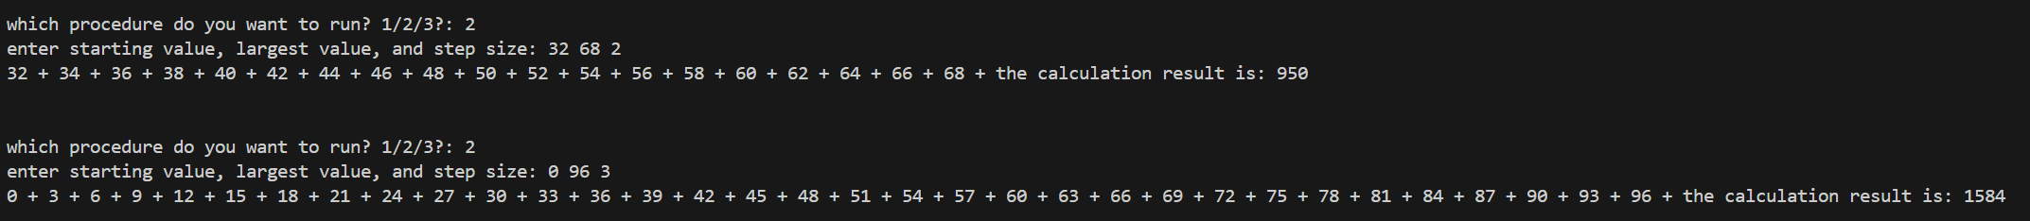

Procedure 3:

